Static Routing – Worksheet

 | Points Possible | Points Awarded
- Enable the necessary interfaces on R3
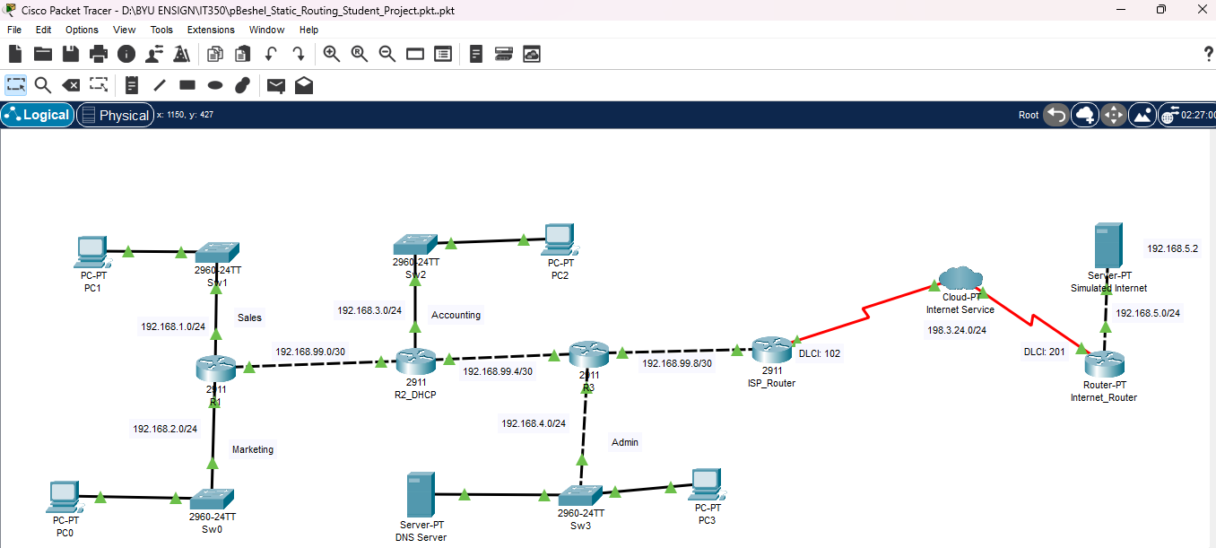 | 1
- Plan and configure routing for your network. Consider using default routes where appropriate to save time. You will full credit for any working configuration. You will need to add routes to all 5 routers for a fully connected network (2 points per router).
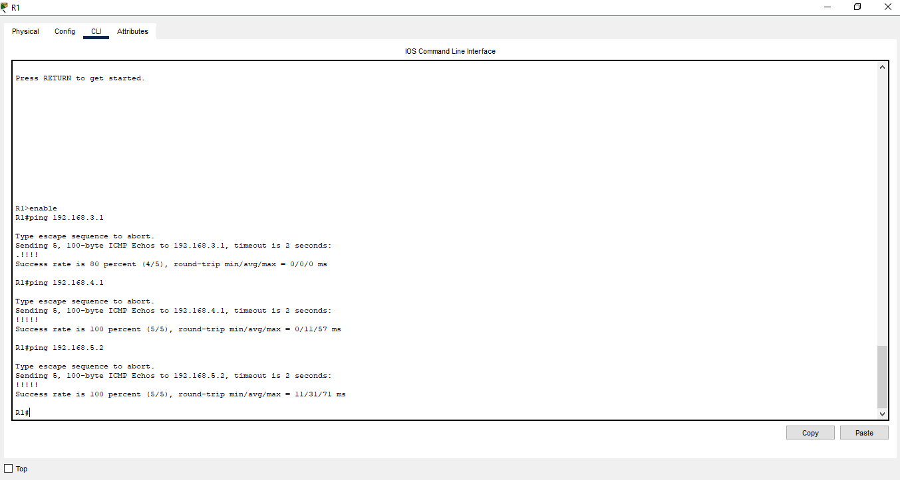  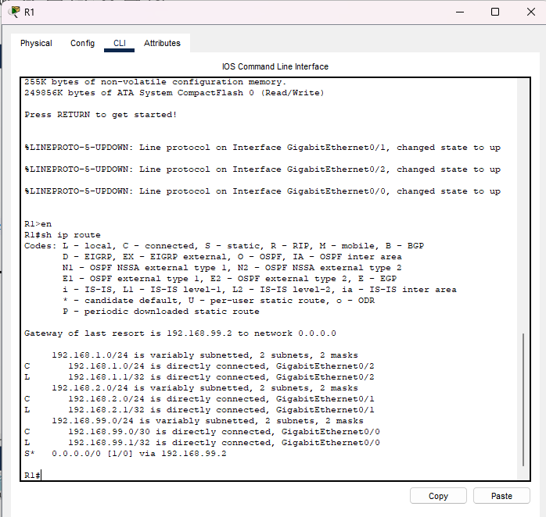  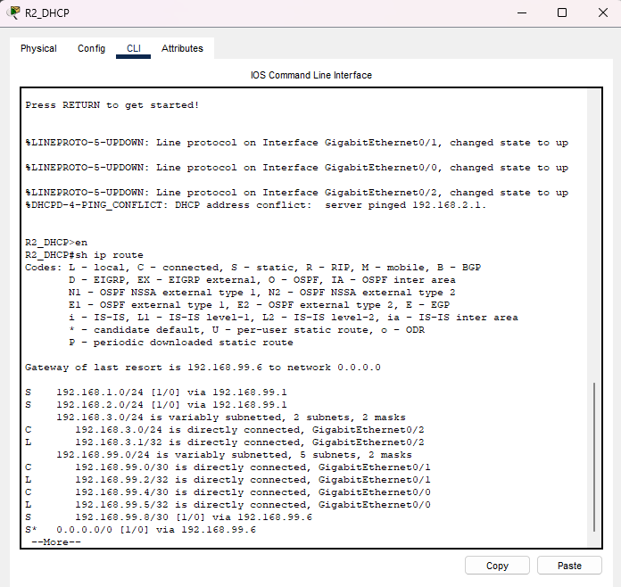  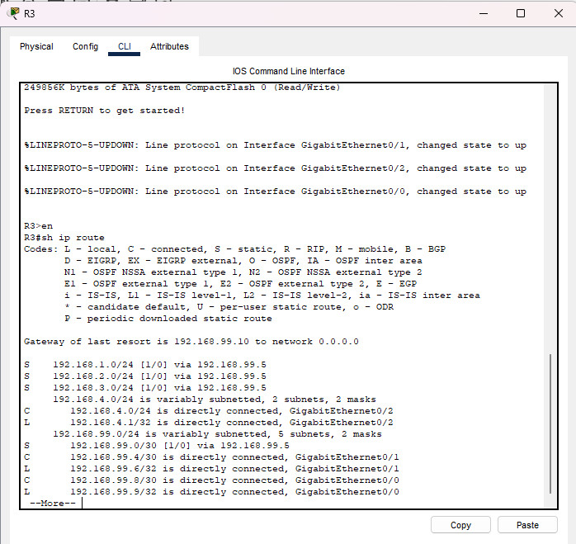  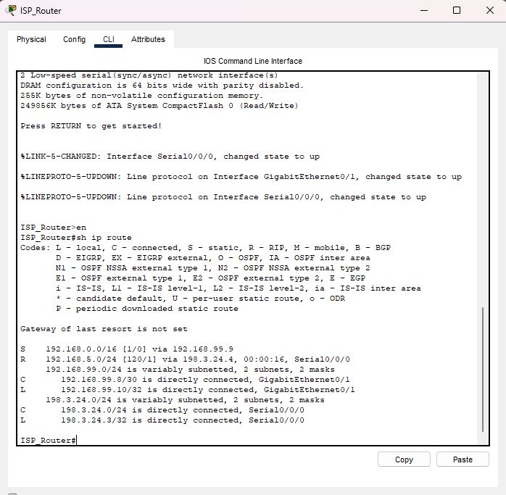  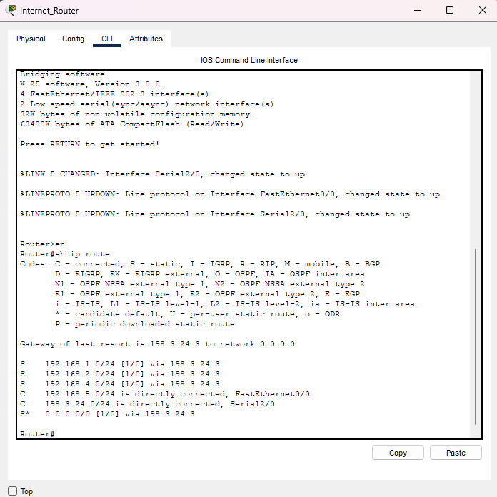 | 10
- Configure ip dhcp pools for all networks. You can pattern your pools after the existing pool for Sales (show run on R2_DHCP). Don’t forget the ip dhcp excluded addresses. You will need ip helper addresses on appropriate interfaces.
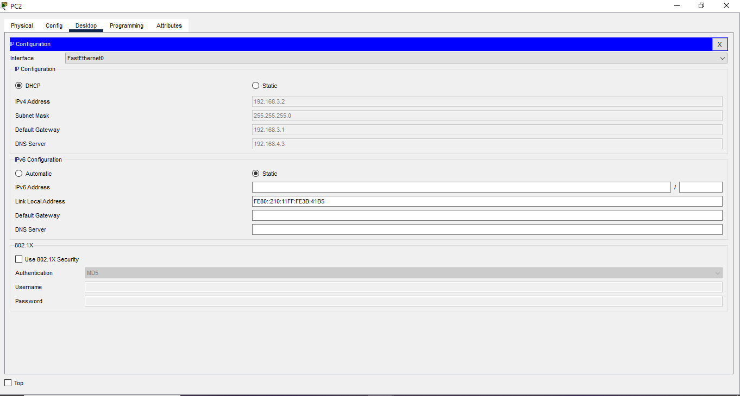 | 3
- Configure all switches with IP addresses and default gateways. From Sw3 ping the IP address of Sw1.

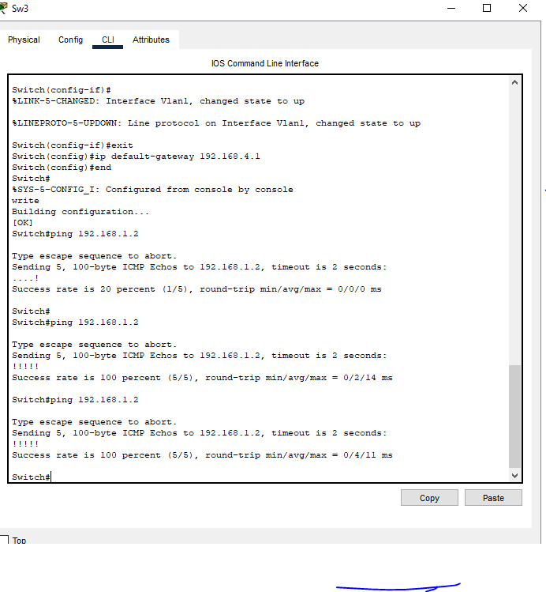 | 2
- Create DNS records on the DNS server (192.168.4.3) for the switches and routers. Create an alias record of www.ralph.com for the simulated internet (192.168.5.2).
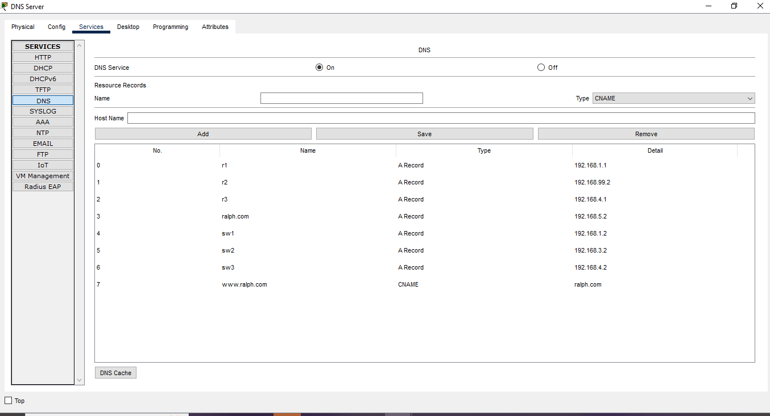 | 2
- Open the web browser on PC0 and enter www.ralph.com in the address bar.

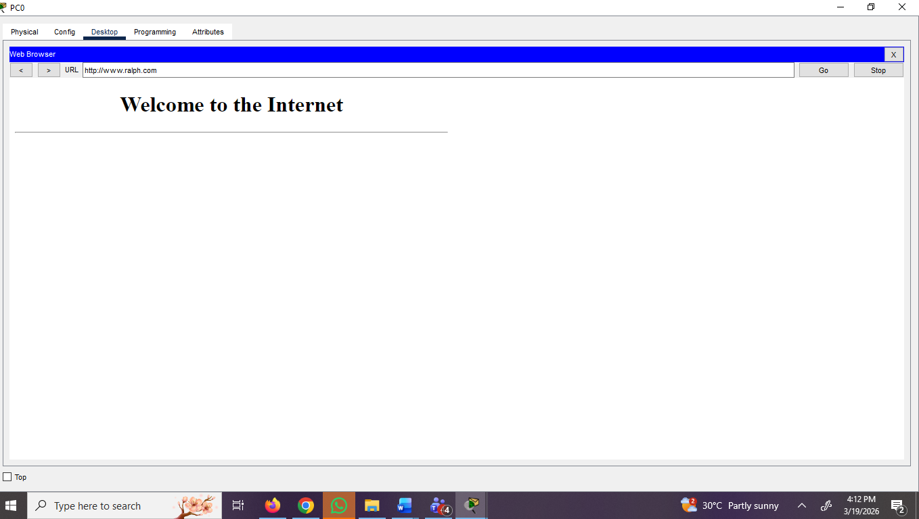 | 1
- Configure the ip name server on all routers and switches. Open Sw2 and ping “www.ralph.com”

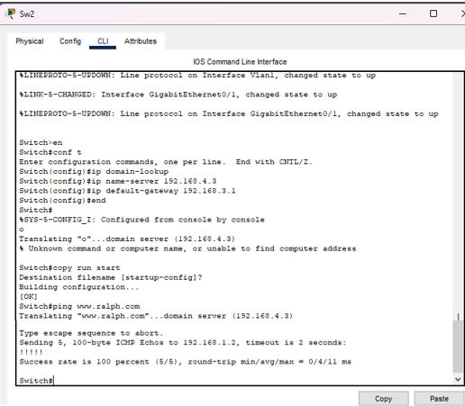 | 1
Total Points | 20

